**Writing a Dissertation (PROM-3)** **Dr. Veronica Alfano (veronica.alfano@gmail.com)**

Centre for Languages and Academic Skills

PROM-3 Questionnaire

**Your name**: Gabriela B. Diaz Cortes

**Project details** (This questionnaire serves as a first draft of sorts; we will revisit all these descriptions and formulations later in the course!)

1. Describe your project in about 250 words. Be sure your description identifies the problem (or opportunity) in society that motivates your research. Include a brief overview of your method.

We want to develop and implement an efficient solver based on the combination of two methods: Proper Orthogonal Decomposition (POD) and deflation to solve reservoir simulation problems.

To extract oil from the subsurface it is necessary to drill wells; however, it has to be done in an optimal way to reduce expenses as much as possible. Optimization strategies are, therefore, developed to minimize the costs and maximize the extraction. Many of the current strategies involve the simulation of large systems of equations. Solving this systems can also be computationally expensive, and new methods have been developed to solve this issue in effective ways. Reduce Order Models (ROM) and deflation techniques exploit the system information to reduce the simulation computing times, by reusing system information . We explore the use of a ROM-based deflation method to speed-up the simulation of flow through large-scale and highly-heterogeneous porous media.  
We present this methodology for reservoir simulation examples, but it can be adapted to any time-varying problem, reducing in this way computational costs.

1. Formulate your main question (that is, the single question that drives and underlies your entire dissertation).

What is a good selection of deflation vectors?

1. Formulate your key questions (that is, the questions you need to answer before you can address your main question).

How can I choose the deflation vectors?

Can I use POD basis vectors as deflation vectors?

How many POD basis vectors lead to an optimal performance?

What is the efficiency of the method?

Can it be improved?

Is it better than other methods/ approaches?

1. What is the (provisional) title of your dissertation?

A development and implementation of efficient Physics based POD Deflation methods to accelerate the solution of reservoir simulation problems.

**Project practicalities**

1. When did you start your PhD project?

August 2014

1. Are you working according to a schedule? yes
2. How many chapters do you expect your dissertation to have? ...................................................
3. If you already have an idea of your chapter titles, please list them here:

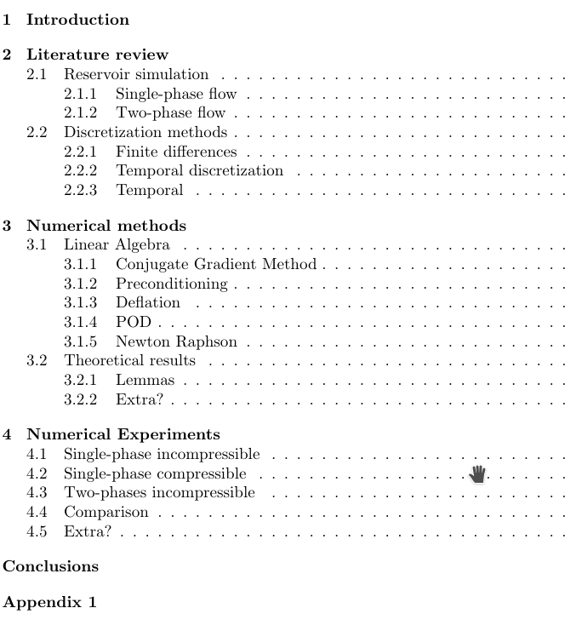

1. How much have you written so far?

Chapter 2.1

3 Reports

2 Conference papers, 1 Journal paper, currently writing a Journal paper.

**This course**

1. Have you taken a writing class before? yes

If so, please provide the following information:

* 1. What was the name of the course? PROM-4
  2. When and where did you take it? Last quarter

1. What do you especially wish to learn in this course?

How different is writing a dissertation from other type of writing.

Now I am starting to write, so I would like to do it in the most efficient way.